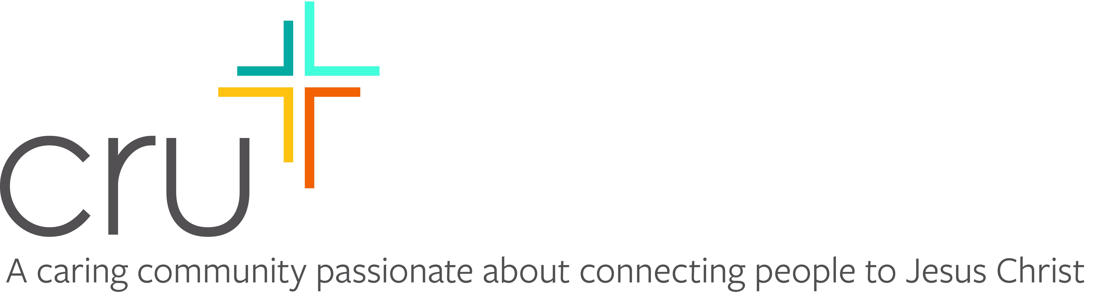

December 6, 2021

Dear

How are you? How have you been managing the cold? We sure have had some pretty cold and snowy weather here in Marquette at Northern Michigan University.

I am writing about an exciting opportunity.

As you may know, I'm involved with a student group on campus called Cru or Campus Crusade for Christ. During Spring Break I plan to participate in a mission trip to Guatemala sponsored by Cru. It will be from February 26 - March 5. We are trusting God for a group of 10-12 from NMU.

Spring Break is a unique opportunity as we don’t have class and we can travel as representatives for Christ. This mission to Guatemala is somewhat new to us in Cru, but an organization called SendMe.org has been sending missions trips to Joyabai, Guatemala for 12 years.

Cru has been hosting spring break trips for over 38 years. Each day we will be taking opportunities to talk to others about our faith, learning about how to apply Biblical principles to our lives and meeting the physical needs of people in Guatemala. We are also partnering with Filter of Hope by giving and demonstrating how to use a water filter that can last 10 years. As you can imagine clean water is rare in this rural country. But the exciting part is that as we give out and demonstrate these filters, we get to explain how the filter is just like our faith in Christ. We will explain that just like the filth and harmful things in this water that need cleaning, so we need to have the spiritual filth and harmful things in our lives that need cleaning from Christ.

Of course we will have translators to help us communicate with the people of Guatemala. We will also have opportunities to show the Jesus Film that was recently translated into the Joyabai Quiche language.

Does it sound scary and exciting? It will be, but we are excited to see how God will be using us. We are trusting God that He will give us the opportunity to lead people to Christ.

We also hope to have some free time, but warmth and sunshine in March will be very nice!! Our hope is that our campus delegation would not leave what we’ve learned in Guatemala, but will bring this training and excitement back to NMU to help reach our campus for Christ.

The entire cost for each student about $1800. This includes $800 for our housing, food and transportation in country. The flights from Chicago will be $450. We will also have transportation to Chicago, an overnight in a hotel and short term international medical insurance. And each of us will bring 2 Filter of Hope filters totaling $80. The rest is a 13% administrative cost with Cru.

I am writing to ask if you would consider helping me attend this exciting missions trip. Would you consider giving a donation of $50, 75 or $100?

We are trusting God to provide through a number of people. If each of us can find 30-35 people, who will give $50-100, we will meet our needs. Any Gifts can me made payable to Cru or Campus Crusade for Christ and sent to me or our Cru Staff Team Operations Leader, Dave Michels. (913 High St., Marquette, MI 49855)

Would you consider helping me go to this unique mission trip?

Thank you for praying about this exciting opportunity to give toward what God will be doing over our Spring Break. I am so excited that I will be able to be a part of this life-changing experience.

Sincerely in Christ,
(Hand written Signature)
P.S. If I don’t hear from you by Feb. 5th I will try to call you. I have enclosed a response card and a return envelope for your convenience. Any gift made payable to "Cru” or “Campus Crusade for Christ" is tax deductible, and you will receive a receipt for it.

