Spring Break on Mission – Panama City Beach, FLORIDA! ! !

Get Ready Get ready for Spring Break on Mission! So start packing your bags for an unforgettable week of fun in the sun and connecting with God! SBOM offers an opportunity to receive some of the best training in evangelism. Feeling stuck with how to talk to your friends about your faith? Learn how to come alongside their spiritual journey and join hundreds of other college students on the beach sharing about the love of Christ.

The Big Break Experience Books? Snow? Cold? Ready for Warm? It's time for Spring Break! Looking for a spring break trip that will grant you time in the sun and challenge you in your walk with God? Stop looking; SBOM is your solution. Spend the week growing in your walk with God, exploring biblical truths and learning how to talk to your friends about your faith. Spring Break on Mission is Cru’s event that gathers students from a number of colleges and universities for a week in Panama City Beach, Florida.

At Big Break you will….

- Worship God
- Hear talks from a dynamic, respected speaker, Roger Hershey
- Spend some personal time with your Creator out on the white sandy beaches
- Receive evangelism training. Learn how to have a conversation with someone that will point him or her to the gospel
- Experience God's power to change lives, as you trust him to initiate spiritual conversations with other students on the beach
- Hang out with your friends and make new ones
- Eat late night snacks at the local waffle house

Transportation: We are Trusting God for great transportation. The usual option is to take cars or vans to Florida. We will hopefully leave from campus at 8 am, on Friday. (NMU – March 1st; ) We will hopefully find a place to sleep for 6-7 hours part way to FL. (Louisville, KY is ½ way) We will arrive into Florida in the afternoon/early evening of March 2nd / March 3rd The first Sunday is mostly a free day. We will leave Panama City, Saturday, March 9th, and will be back into the UP in the early evening of March 10th / March 12th For safety we will have 2 people awake in each vehicle at all times. The driver & someone “riding shotgun” who will keep the driver awake & navigate.
As far as the cost of transportation, please plan on $120 to $170. The idea here is that the owners of the cars will not pay gas costs and will get an oil change for the use of their vehicles. This plan is much cheaper than rental vehicles. A rental car would cost $600-700 plus gas. We will collect all the money up front and someone will the pay all the bills. We will rebate everyone at the end, depending on how much we actually spend.

Housing: We will be staying at the beautiful SandPiper Beacon Resort. (Check out the picture on the web page). https://www.sandpiperbeacon.com/

It’s right on the beach and it has a pool. Each hotel room/unit has 2 bedrooms, a efficiency kitchen and a bathroom. There is also a pull-out sofa in each unit. They are nice units!! There will be 8-10 people sleeping in each unit. (Lots of bonding time) Here are the specifics on the resort: SandPiper Beacon Resort, 17403 Front Beach Rd, Panama City Beach, FL 32413, telephone number is (850) 234-2154 Please pass this information on to your parents.

Spiritual Preparation: This will be a great conference and we need to be talking to the Lord about it before we get there. We also need to be prepared to be sharing our faith with people. Please read through the Knowing God Personally booklet with at least two people before we leave for the conference. Pray for our travel, safety, harmony among our group, safe running vehicles and for hearts prepared to hear the gospel. Pray also for yourself, the speakers, and for opportunities to talk to those who need to know Christ.

What to Take: PACK LIGHT!!!!!! We only have so much room in the vans. Limit yourself to 2 small SOFT-Sided bags. You can always wash stuff down there. Here are some ideas on what to take along: 1 pair jeans, Shorts, T-shirts, swimsuit(Please be modest!), Sweatshirt (It can be cool at night) Light jacket/ raincoat, toiletries, sunscreen 15+SPF, (your pasty white thighs will fry if you aren’t careful), Bible, Notebook/paper, Pillow for travel, Sandals, Sunglasses, Beach Towel, Small Backpack.

Finances: This is the area for you to see God work on your behalf in the greatest way.

Housing Cost: $359 for the week. (You MUST pay in full & register Online) IMPORTANT! Housing is limited to the first 35 people. Registration will close when they are full. Don't get left our Register Early!

Transportation: $120-170 in cash; due when we leave. Fun/ gifts: $???$ - Friday is free day. Options could include Golf, Fishing, Rentals, etc.

Food: $100-130 for food as we travel & for food at resort in Panama City Beach. Scholarship money can be used for all these items.

The Money Solution: God is in the business of providing for our needs. Money is not a problem for God. We can trust HIM to provide for us, especially when it will be used to develop us spiritually. God might supply using a number of means. But we have seen God supply miraculously by asking for a scholarship. By writing & asking for a scholarship from your home church or Christian friends or just people that you know exciting things can happen. If you will write 25-30 letters simply presenting your need and the reason for your trip you will be amazed at how generous people will become. (See Fund Development Info Document / Letters) By personally asking for gifts for a mission trip, where we are doing evangelism, you should find that people are quite eager to give. Gifts that are given as a tax deductible gift need to be sent to Cru / Campus Crusade for Christ. See Online giving site.
- Because of the costs to process checks within Cru / CCC, there is a 12% charge for all scholarship checks that are processed as donations. If a local church is helping you with a donation, that 12% is not applied.
- You need to have the checks in hand, before scholarship can be applied to your conference costs.

Responsibilities: We will need various people to take on responsibilities for the Trip. If we split up the various jobs 1 person won’t get as stressed out or feel like the tyrant all the time. Let Dave M. know if you are interested in any of these jobs. Other jobs maybe created as the trip goes on.

Jobs: MoneyMan / Financial Female; Spiritual Guru; Trip Boss; Mrs. Maps / Mr. Shotgun; Chef Tell; Fun Fellows; Lackey

For More Information: Call ________________ _____________ or Dave Michels 906-228-4438 Dave.Michels@Cru.org
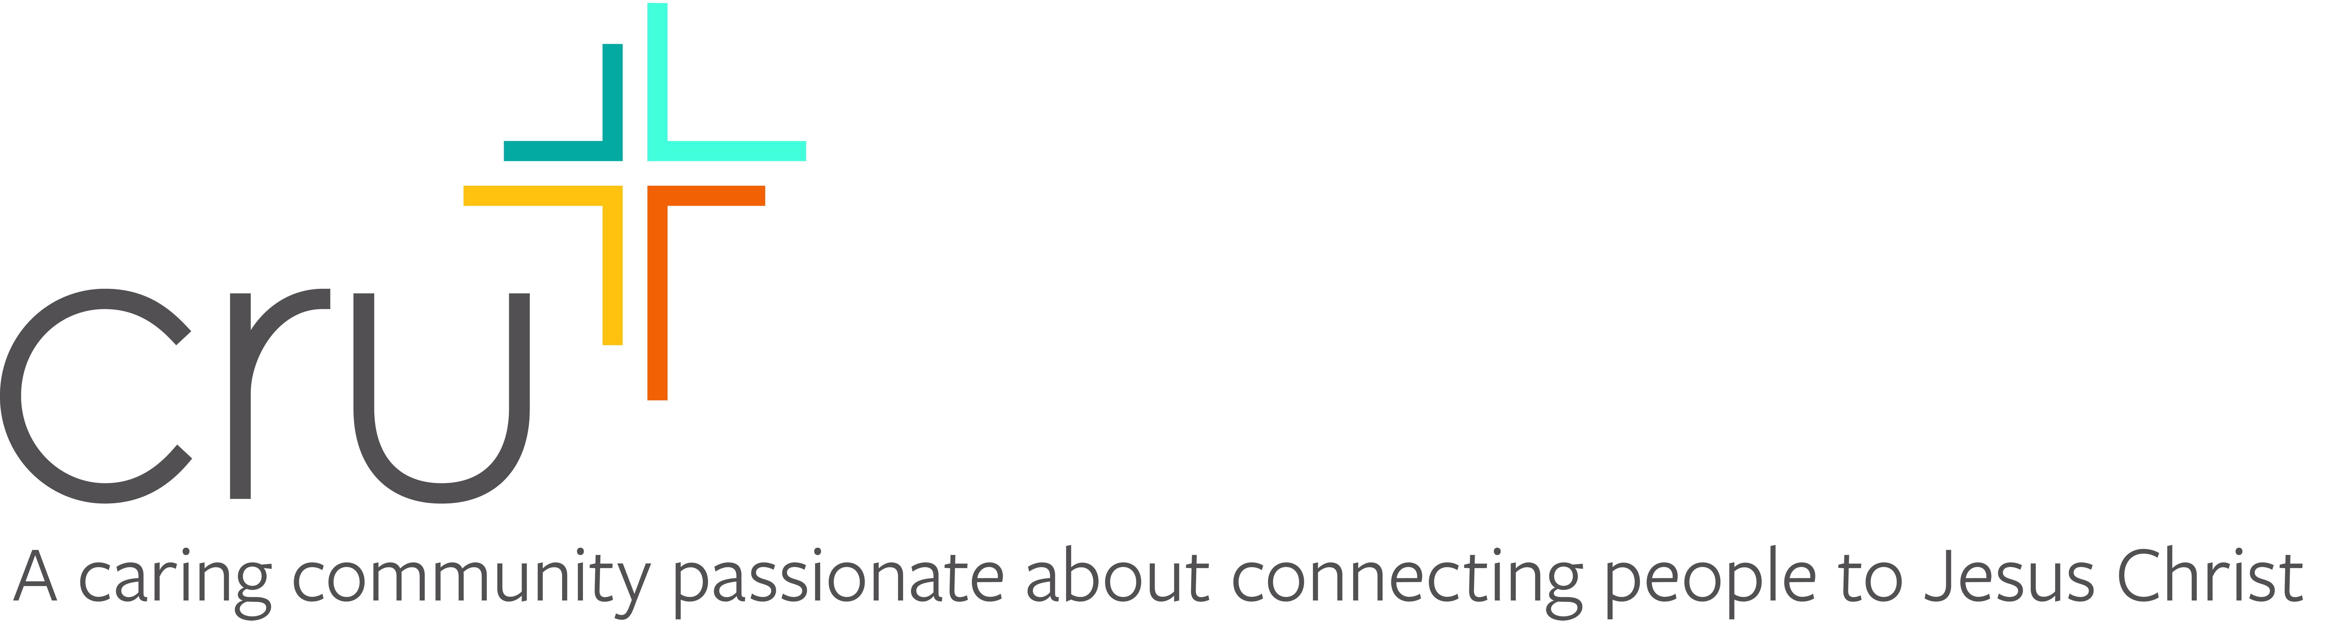

February 1, 2024

Dear

How are you? How have you been managing the cold? We sure have had some pretty cold and snowy weather here in Marquette at Northern Michigan University.

I am writing about an exciting opportunity.

As you may know, I'm involved with a student group on campus called Cru (formerly Campus Crusade for Christ). During Spring Break I plan to attend a conference sponsored by Cru in Panama City Beach, Florida, March 3 - March 16. We are trusting God for a group of 10-15 from NMU and we will be joined by other college students from across the state.

I’m sure you may be thinking that Spring Break in Florida is a just a wild party. Cru has been hosting spring break trips for over 45 years. Each day we will be learning about how to apply Biblical principles to our lives and how to talk to others about our faith. Each afternoon we have the privilege and opportunity to head out to the beach and initiate conversations about knowing God. Does it sound scary? It will be, but we are excited to see how God will be using us. We are trusting God that He will give us the opportunity to lead people to Christ.

We will also have some free time and Florida sunshine in March will be very nice!! Our hope is that our campus delegation would not leave what we’ve learned in Florida, but will bring this training and excitement back to NMU to help reach our campus for Christ.

The entire cost for each student about $680. This includes $359 for the Spring Break on Mission, which includes registration and housing. Transportation and our meals are extra. We are hoping to drive a number of vehicles down to Florida. That should be about $130. Food should cost about $100-130. The rest is a 12% administrative cost with Cru.

I am writing to ask if you would consider helping me attend this conference. Would you consider giving a donation of $50, 75 or $100?

We are trusting God to provide through a number of people. If each of us can find 20 people, who will give $50-100, we will meet our needs. Any Gifts can me made payable to Cru or Campus Crusade for Christ and sent to me or our Cru Staff, Dave Michels. (913 High St., Marquette, MI 49855)

Would you consider helping me go to this conference?

Thank you for praying about this exciting opportunity to give toward what God will be doing over our Spring Break. I am so excited that I will be able to be a part of this life-changing experience.

Sincerely in Christ,
(Hand written Signature)

P.S. If I don’t hear from you by Feb. 20th I will try to call you. I have enclosed a response card and a return envelope for your convenience. Any gift made payable to "Cru” or “Campus Crusade for Christ" is tax deductible, and you will receive a receipt for it.

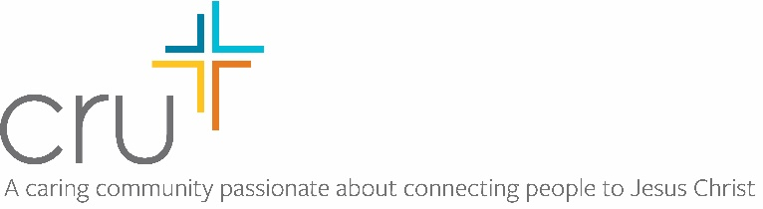

February 1, 2023

Dear

How are you? How have you been managing the cold? We sure have had some pretty cold and snowy weather here in Houghton at Michigan Technological University.

I am writing about an exciting opportunity.

As you may know, I'm involved with a student group on campus called Cru (formerly Campus Crusade for Christ). During Spring Break I plan to attend a conference sponsored by Cru in Panama City Beach, Florida, March 4 - March 11. We are trusting God for a group of 10-15 from MTU and we will be joined by other college students from across the state.

I’m sure you may be thinking that Spring Break in Florida is a just a wild party. Cru has been hosting spring break trips for over 45 years. Each day we will be learning about how to apply Biblical principles to our lives and how to talk to others about our faith. Each afternoon we have the privilege and opportunity to head out to the beach and initiate conversations about knowing God. Does it sound scary? It will be, but we are excited to see how God will be using us. We are trusting God that He will give us the opportunity to lead people to Christ.

We will also have some free time and Florida sunshine in March will be very nice!! Our hope is that our campus delegation would not leave what we’ve learned in Florida, but will bring this training and excitement back to NMU to help reach our campus for Christ.

The entire cost for each student about $625. This includes $299 for the Spring Break on Mission, which includes registration and housing. Transportation and our meals are extra. We are hoping to drive a number of vehicles down to Florida. That should be about $130. Food should cost about $100-130. The rest is a 12% administrative cost with Cru.

I am writing to ask if you would consider helping me attend this conference. Would you consider giving a donation of $50, 75 or $100?

We are trusting God to provide through a number of people. If each of us can find 10 people, who will give $50-100, we will meet our needs. Any Gifts can me made payable to Cru or Campus Crusade for Christ and sent to me or our Cru Staff, Dave Michels. (913 High St., Marquette, MI 49855)

Would you consider helping me go to this conference?

Thank you for praying about this exciting opportunity to give toward what God will be doing over our Spring Break. I am so excited that I will be able to be a part of this life-changing experience.

Sincerely in Christ,
(Hand written Signature)

P.S. If I don’t hear from you by Feb. 20th I will try to call you. I have enclosed a response card and a return envelope for your convenience. Any gift made payable to "Cru” or “Campus Crusade for Christ" is tax deductible, and you will receive a receipt for it.

